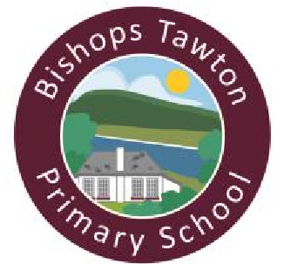 **Two Rivers Federation**

**Bishops Tawton Primary School**

Phone: 01271 343002

Email: admin@bishopstawton-primary.org

Executive Head Teacher: Melanie Smallwood Website: [www.bishopstawtonprimary.devon.sch.uk](http://www.bishopstawtonprimary.devon.sch.uk/)

Head of School: Karen Lintin

# Reading

Thank you to those of you who have logged your child’s reading on the Boom Reader app. I would love to hear your feedback on this compared to writing in the home learning books. Please let me know your thoughts (face to face or email).

# Tarka class learning

On Monday, Tarka class enjoyed the year 6 fundraising event. They had the chance to play games and buy treats. All profit is being donated to the Amigos charity.

In Forest School, the children identified common garden plants by observing and feeling real plants and matching them to the correct pictures.

We had an exciting morning on Thursday, moving to our new classrooms and meeting the teachers and adults who will be working in each class. Hopefully your child told you all about it!

The children have worked hard to complete their prints, on paper and canvas bags, for the gallery on Tuesday. They can’t wait to share their work with you!

# Home Learning

It’s going to be really hot this weekend, enjoy the sun safely!

Design an ice lolly/ice cream that would be perfect for cooling you down in the hot weather. What flavour would it be? Would it have any toppings? Can you think of a way to stop it from melting so quickly?

