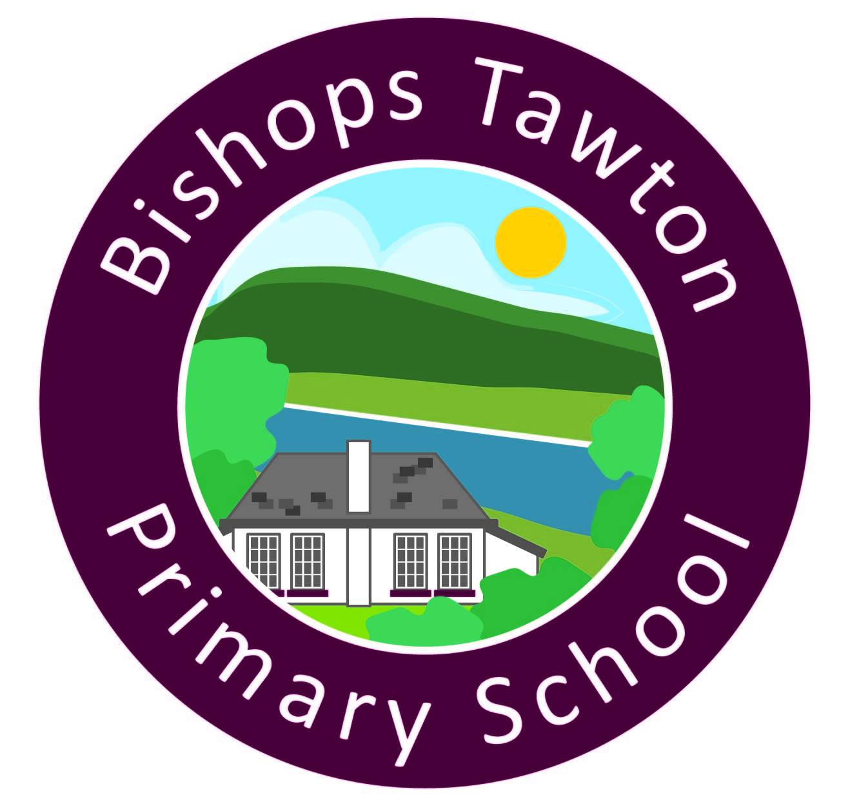

Two Rivers Federation

**Bishops Tawton Primary School**

Phone: 01271 343002

Email: [admin@bishopstawton-primary.org](mailto:admin@bishopstawton-primary.org)

Website: [www.bishopstawtonprimary.devon.sch.uk](http://www.bishopstawtonprimary.devon.sch.uk)

Executive Head Teacher: Melanie Smallwood

Head of School: Karen Lintin

**Exmoor home learning**

This week, we have been practicing writing skills, based on Leon and the Place Between, in English. In maths, we have been learning to round decimals to the nearest whole number and tenth. In history, we have been historical detectives and used evidence to work out which historical era we will be studying this term.

**Home learning**

It is World Earth Day on 22nd April 2024. Your homework is to do something to look after our world - this could be planting some flowers, making some junk modelling art or taking part in a beach clean. We would love to see photos of what you get up to!

**Reading**

We expect everyone to be reading for at least five minutes a day and record this in their yellow reading journals.

**PE Our PE day is Wednesday. Please ensure long hair is tied back and jewellery is removed for PE days.**

**Times Table Rock Stars**

Our Year 4s will soon have a new challenge on their accounts against Langtree’s year 4s. Log on to see it go live!

**DT materials**

We will soon be making our bags in DT. We can supply plain white fabric for every child, but if your child would like a particular pattern or colour, please could they bring in 1m square of the fabric they would like.

     



